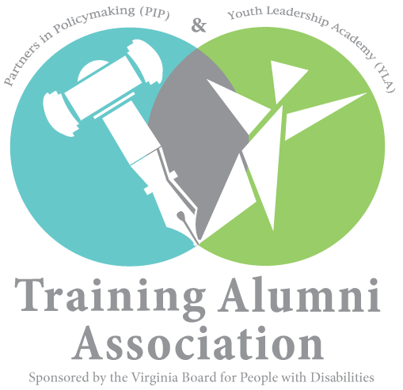

We, the members of the Training Alumni Association (TAA), an organization funded by the Virginia Board for People with Disabilities (VBPD) is comprised of graduates from the VBPD Partners in Policymaking (PIP) and Youth Leadership Academy (YLA). Our mission, is to engage in grassroots advocacy on behalf of Virginians with disabilities.

Our TAA Alumni represent four regional chapters across Virginia: Central (CVA); Northern (NoVA); Tidewater (TARC); and Southwest (SWA). The TAA Elections Subcommittee commends the Virginia Department of Elections for its efforts in providing accessible voting options such as curbside voting which provides the opportunity for voters with disabilities and senior citizens, the right to vote without leaving their vehicle.

Voting, as you know, is an American principle and a basic democratic right that should be protected, promoted, and practiced. The 26th Amendment of the Constitution of the United States of America says the right of citizens of the United States, who are eighteen years of age or older, to vote shall not be denied or abridged by the United States or by any State on account of age.

In conducting our research we understand the following:

- If you are 65 or older, or have a physical disability, you may vote on Election Day without leaving your vehicle.

- If you would like to use curbside voting, remember to bring a helper with you who can enter the polling place to ask an election officer for curbside assistance.

People with disabilities have encountered several challenges and inconsistencies at numerous polling locations across the Commonwealth. We believe that the current language and practices is unfair and discriminatory and therefore, violates the Americans with Disabilities Act (ADA).

ADA is a civil rights law that prohibits discrimination against individuals with disabilities in all areas of public life, including jobs, schools, transportation and all public and private places that are open to the general public. The purpose of the law is to make sure that people with disabilities have the same rights and opportunities as everyone else.

Therefore, the TAA finds that your current practices of curbside voting across the Commonwealth are discriminatory and in violation of Title III of the Help America Vote Act (HAVA) on the grounds that persons without disabilities are allowed to vote without the need for a helper to accompany them to exercise their constitutional right.

The TAA strongly recommends the following be immediately implemented by the Secretary of Administration, the State Board of Elections, and the Commissioner for the Virginia Department of Elections:

- Recommends the Virginia Department of Elections, the General Registrar, and local voter registration offices require all polling locations to designate a polling officer be stationed curbside, at the entrance of the polling location door to provide assistance to people with disabilities and seniors to be able to vote in the same private and independent manner as a voter without a disability.

- Recommend that an alarm system or remote bell be installed at ALL POLLING LOCATIONS, so that election officials are immediately notified when a curbside voter arrives at the polling location.

- Recommend that curbside voters be notified by an election official of the anticipated wait time which should not exceed 5-7 minutes after being notified of arrival as extended wait times could result in detrimental medical complications.

Thank you for your attention to this most urgent matter. We trust that our recommendations will be reviewed and adopted as soon as possible in order to ensure that people with disabilities and senior citizens in the Commonwealth of Virginia can exercise their constitutional right to vote curbside without barriers at any and all polling stations throughout the Commonwealth of Virginia.

Advocating from conviction for a life like yours,

The Training Alumni Association (TAA)

The views and opinions expressed by the TAA are those of the TAA and do not necessarily reflect the official policy or position of The Virginia Board for People with Disabilities.

